Assignment by Levi Diyali
BCA 3rd Semester
Project: Anime Archive
Web Technologies I

Site Map:
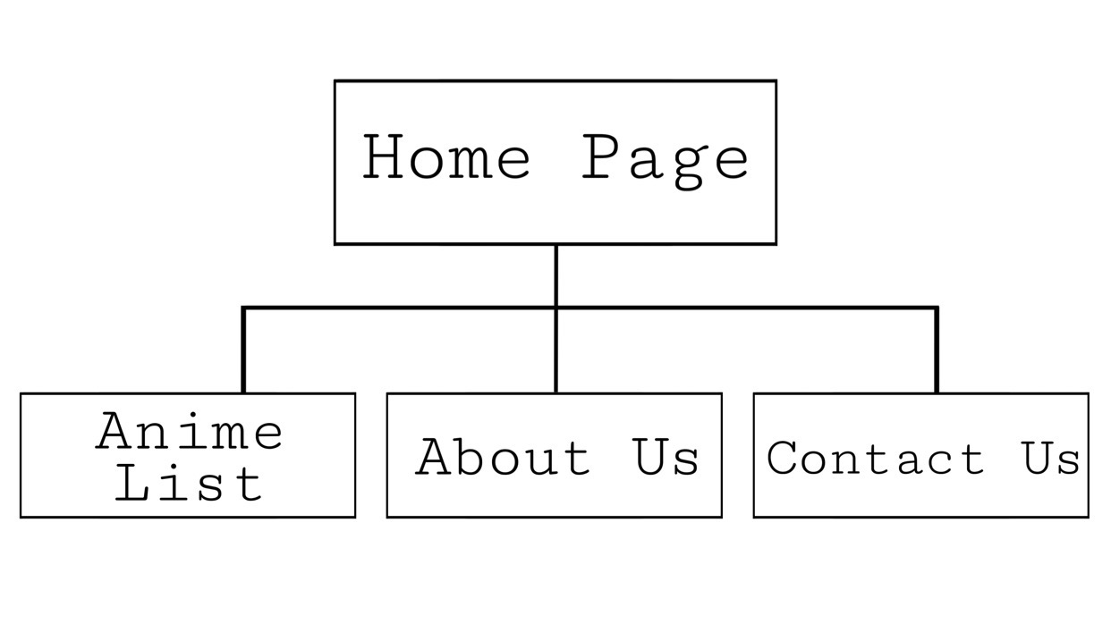

References used:
Pictures: Google
Website details:
https://gamerant.com/best-comedy-anime-series/
https://anikai.to/home

